**Assignment objectives:**

Git manipulation

Test design

BDD – implementation

**Hint**:

Please do not hesitate to contact [michal.crkon@amcsgroup.com](mailto:michal.crkon@amcsgroup.com) if you have any issues or questions or your task requires extra clarification.

**Deadline:**

Usually, 5 working days

**Requirement:**

Create a new public Git repository.

Create any BDD framework (Preferable Cucumber, Cucumber-JS, Specflow, Behave or Lettuce) by using any programming language.

Task A.

1. Navigate to https://www.amcsgroup.com/
2. Click on English (or any predefined language)
3. Verify that in drop down are options:Netherlands, Deutch, Espanol, Dansk, Francais, English (United Kingdom)

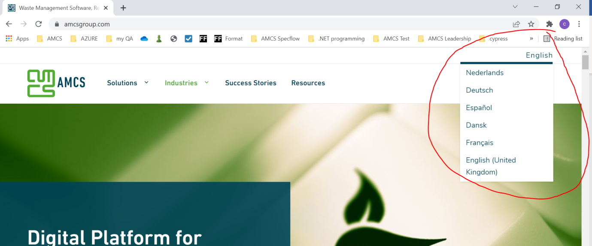

Task B

1. Navigate to https://www.amcsgroup.com/
2. Click on English (or any predefined language)
3. Verify that in drop down are not options: Slovak, Irish, undefined

Task C

1. Navigate to https://www.amcsgroup.com/
2. Navigate to the bottom of the page or simple click on the option Careers on the bottom of the page
3. Verify that you are redirected to [https://www.amcsgroup.com/careers/#](https://www.amcsgroup.com/careers/)

Task D

1. Navigate to [https://www.amcsgroup.com/careers/#](https://www.amcsgroup.com/careers/)
2. Verify that filters contain Countries United States, United Kingdom, Australia and Ireland but not Slovakia, Poland and Papua New Guinea

Task E

1. Navigate to [https://www.amcsgroup.com/careers/#](https://www.amcsgroup.com/careers/)
2. Verify that filters categories contain Professional Services and Sales Marketing but does not contain Fishing, Hunting and Driving

Task D

1. Navigate to [https://www.amcsgroup.com/careers/#](https://www.amcsgroup.com/careers/)
2. Click on Filters -> Countries ->Ireland
3. Verify that URL is changes to <https://www.amcsgroup.com/careers/?countries=ireland>

Images:

Filters Countries

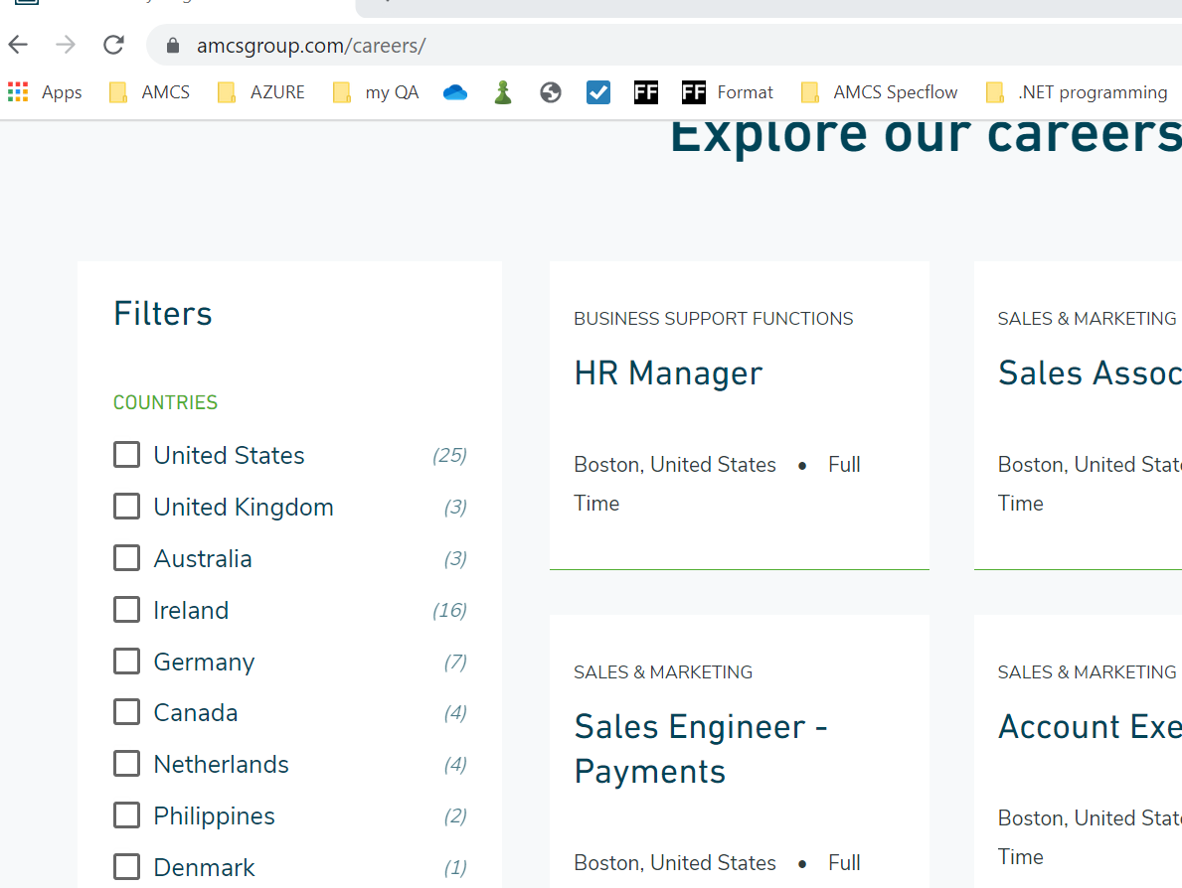

Filters Categories

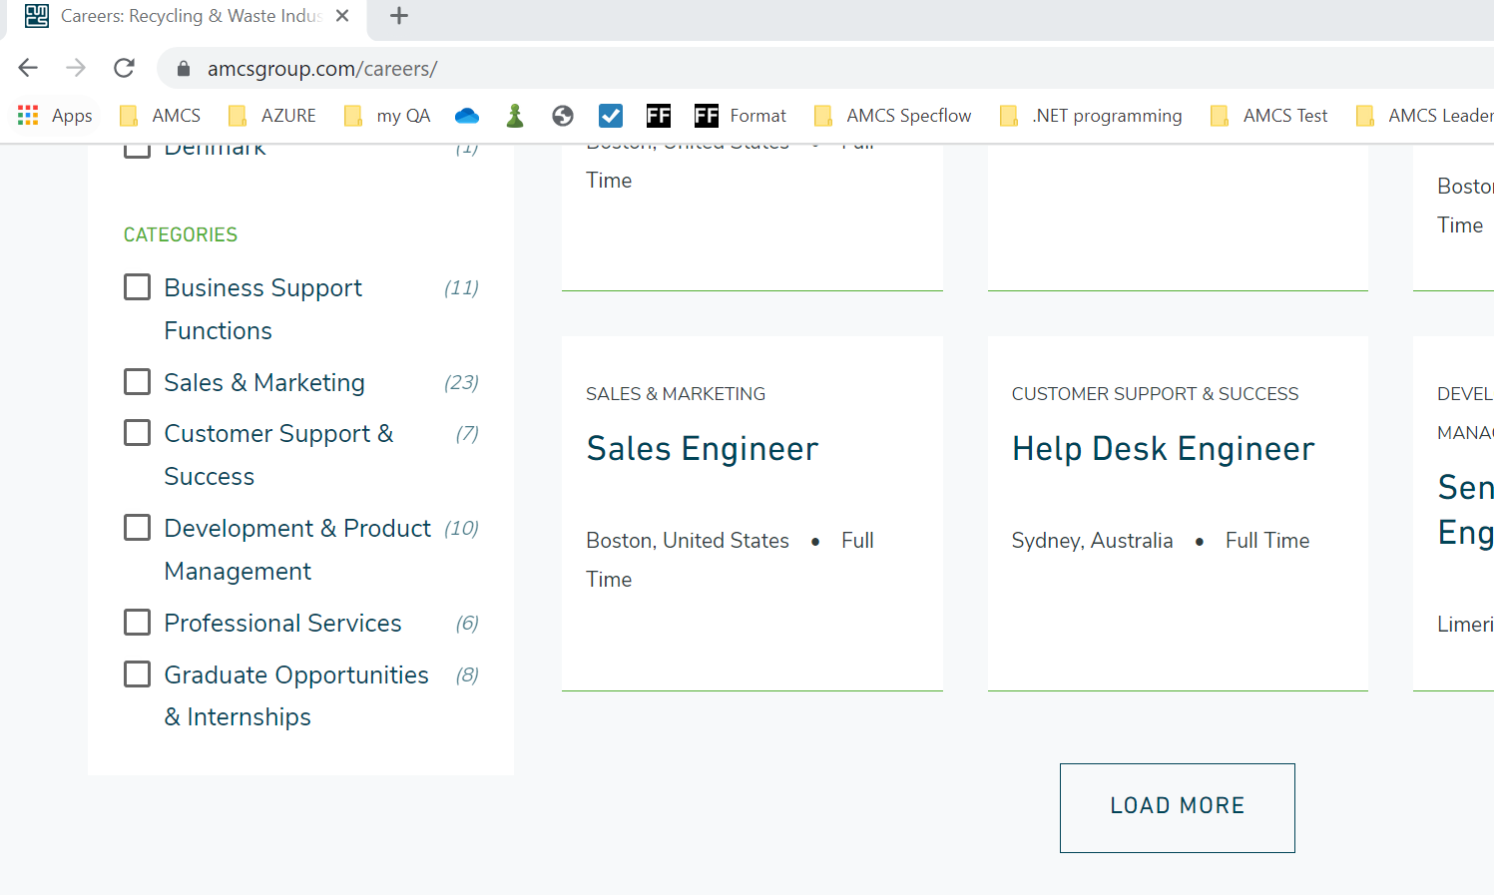

Ireland selected

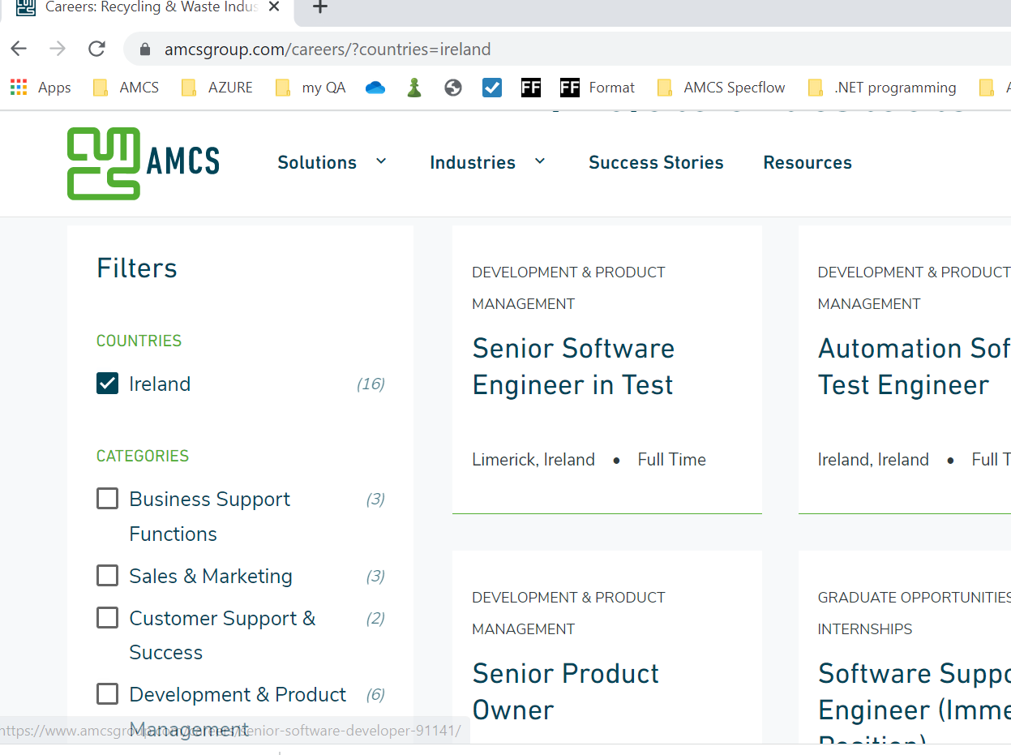

The test design is fully up to you. If you need extra clarification, please do not hesitate to contact us.

**Flow explanation for the framework designed:**

Packages are created for feature, Step definition and Test run.

Prerequisite: Pom.xml file is imbedded with all the required dependencies.

Features package contains the scenarios for the tasks allocated as per cucumber framework.

In terms of Given, When, Then and And at relevant scenarios.

Using Gherkin –template is created for Step definition.

Selenium code Infused for each step of the scenario.

Test Run package:

Defines the location of the features file and step defination locations.

Using the test can be run using TestNg.

**Best practices:**

Always cross verify the versions while infusing the dependencies.

Infuse all required dependencies prior to test cases.